Design idea/concept 5 (Education) - Kayes and Moriom (Mutual Contribution)

1. Learning Issue:

A small town with a 40-kilometre size, Bamaga is located in the northern part of Queensland, Australia. It is a region of NPA with a population of approximately 1164. There are 20% of them.75% of islanders are indigenous. (Thomas, 2018). The educational issue is among the most crucial problems to bring up since good education for city dwellers will help them learn about technology, which will help them obtain more jobs in the field to raise their standard of living. The main obstacles to education are inadequate Aboriginal role models and irrelevant teaching materials. The community and informed parents must work well together to support Bamaga’s education.

In rural places, there is a severe lack of English teaching resources. In remote places, English is not the primary language spoken by pupils who identify as Aboriginal. An assessment of current textbooks revealed that Aboriginal history receives little attention.

Books primarily discuss non-Aboriginal people's experiences and only briefly mention the lives of Aboriginal people. (Jens Korff, 2022). More than a quarter of Australian educators who were surveyed concur that they lack the training required to educate Aboriginal pupils properly said Jens Korff (2022). Recent research found that in the Northern Territory, only 47 cents of every dollar spent on public education went towards instructing students in remote communities.

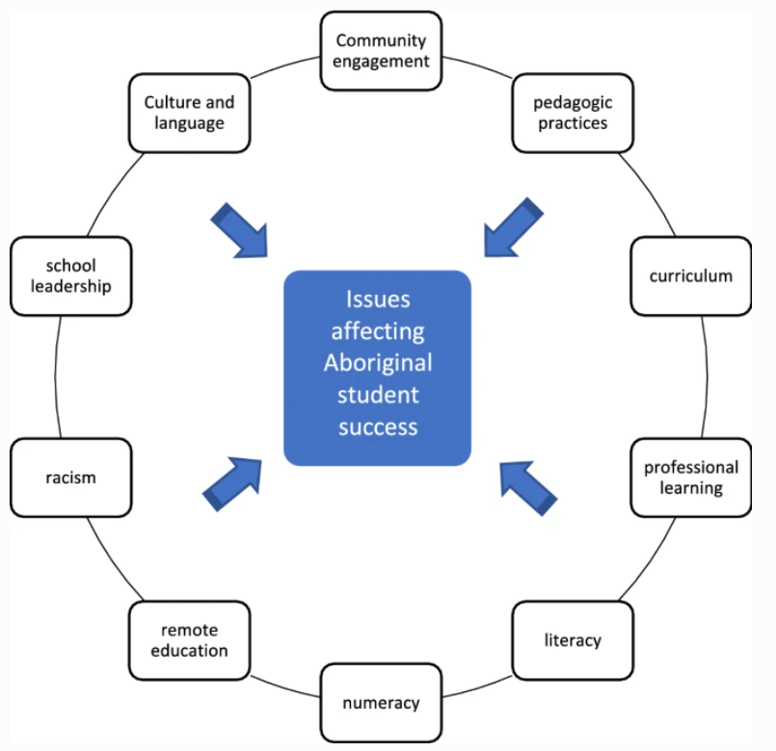

Figure (Lowe et al., 2019)

Here are some potential learning issues to Bamaga Students and local people that is related to education.

1. Lacking in teaching Materials

2. Limited Aboriginal Academics

3. Poor Teaching quality

4. People are not willing to learn

5. Not enough awareness for education

6. Lack of infrastructure

7. Segregation by skills levels

2. Design Concept:

The design we are going to make specifically for the people of Bamaga that mainly provides them the easiest way to get access for education using the Digital connectivity infrastructure for remote communications. In our design, we will provide them an online Education platform by providing them free high-speed internet that covers a wide area. Our main idea is to provide a cybercafé where local students of that area including the mass people of all ages can make them educated by themselves. They can access that cybercafe anytime that is totally free of cost.

There, they can access computer with internet where they can study, research, learn and develop new skills etc. But before that, we need to teach them how to access that cybercafe and how to use or operate computer for learning purpose and for that reason we will create an online learning platform where they will teach themselves by the guide of a tutor who is well educated enough to teach them about that platform.

In that online education platform, all the studying data, information will be stored that can be accessible by all the people of that area. There will be all kinds of educational contents, technical skills learning, daily life skills etc to educate the people of Bamaga, so, that they can implement that in their daily life in a very convenient way to make their life easy.

For this design, we will set up 20 computers in one cybercafe, there will be routers that will provide wireless network to get access the internet. We might need to use server to store all the data of that online education platform. To properly set up the whole thing we will need to deal with some professionals of that area. The cybercafé will connect to the internet by the LAN that has to relate to a local tower. That tower will get information, data from a cloud server where all the data will be stored by the help of a satellite. And so, we also need satellite to implement the whole idea properly.

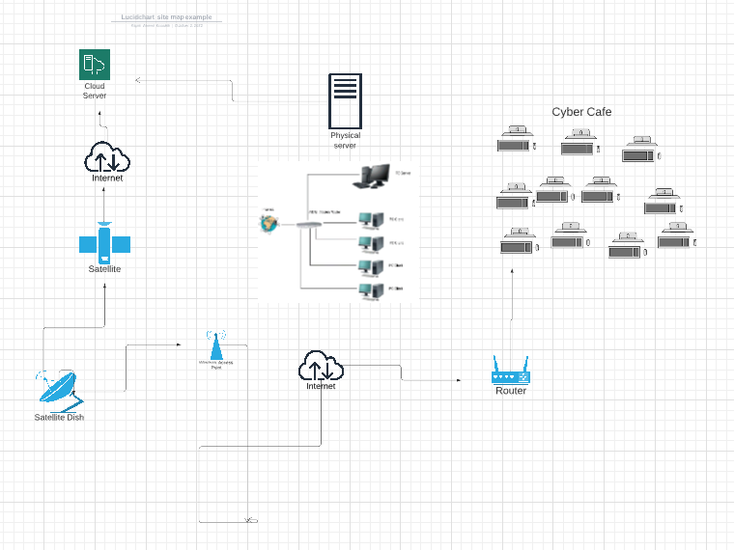

3. Design Outline:

For the project design we are going to use these devices down below

LAN, Router, Cloud Server, Internet , Network Tower , Computers , Projectors ,Satellite.

The idea of universal access to the internet is so intriguing. It is a genuinely amazing fantasy, and one that will someday come true, to think that everyone in the globe will be able to witness this phenomenon. Currently, the majority of places can connect to the Internet, but many isolated places still cannot. Remote locations require the provision of wide area network (WAN) links.

Wide area networks are an idea that has been around for a while but is still significant in networking today. These networks are what bind together the entire Internet thanks to their numerous links. There are other network types that offer access like this as well, such as metropolitan area networks (MAN), which are effectively a WAN and a LAN combined in a more defined space, but that isn't the subject of this guide.

We also require devices. But when it comes to gadgets, we also require the ones that connect us in addition to the amazing tech that translates the Internet into language we can understand. Analog to digital and digital to analogue signal conversion is done via modems. the apparatuses that send the signal out into space or along the wire connecting us to the other side. The equipment to meet us on the other side.

Anyhow, the next step would be to distribute the access after you have the modem's service connection created and it can communicate with the ISP and access the Internet! Although hardwired routers exist, wifi routers are quite prevalent in all contexts. In order to provide everyone with that amazing Internet connection, one or both of them (depending on the end user equipment you have) will need to be plugged into the modem. (Abraham, 2019)

4. Design Benefits:

a. Access & Equity:

We have come with a solution that can be accessible by all mass people of that area 24 hours. Anyone can access that Cyber café for any kind of learning purpose, research etc. Since we are providing free high-speed internet with maintaining safe Search for the people under 18, they can get the best out of it and implement in their daily life and make the best use of technology.

b. Health & Safety:

This project is mostly focused on Education, but it can be used for other purpose as well. By providing free internet in Bamaga, we can make awareness about health and safety among the people of that area.

c. Appropriateness:

The Design idea we are sharing for this project is basically for the people of Bamaga and we did our best to cover all the criteria and requirements of the project and hopefully it will cover up everything, specially from the education side.

d. Affordability:

We tried to reduce the cost as much as possible. The devices and hardwires we are going to use for this project are so affordable in terms of use and cost. We might need satellite access to implement this idea and we need some specialist to set up the whole project in Bamaga.

e. Environmental Health:

In this whole project we kept that in our mind to make sure the project is environment friendly, and we were kept our promise. We did make sure that this project doesn’t affect the environment.

f. Sustainable Livelihoods:

Natural resources won't be impacted, and no other development will be affected because of this design concept.

5. Design Specifications:

We are going to be using different types of network devices for our project. We need mostly network devices like routers, LAN, Network tower, Wireless network point, internet provider and lastly satellite. To transmit the data to the internet, we also need access to satellite.

Due to the low cost, low power consumption, and low bit rate of Connected devices, the data centres will assist in storing the data from these devices before sending it to the router. To access the data, the router will assist in sending the data to a wireless access point. As we need to alert, the router will also broadcast the data to a LAN network.

6. Design Constraints:

❑ Resources:

We are using a lot of network devices and professional people to implement the whole idea properly in a good way. We are using most networking devices cause it’s all about Online education learning platform using digital Connectivity Infrastructure. We are using routers, LAN, computers, Wireless network access point, server, cloud server etc for this project.

❑ Advantages:

There are a few disadvantages for this project. Since most of the people have no knowledge in technology and in other digital connectivity infrastructure as well. So, it would be kind of difficult to teach them about this kind of stuff.

❑ Disadvantages:

For those with limited resources, an Internet café allows access to the Internet (Adetoro, 2010). Internet cafés are a type of informal learning setting where social contact is at the centre of offering drop-in access to computers and the Internet for hourly rates. (Hansson & Wihlborg, 2009).

Since our main goal is to provide them the best and convenient project idea to solve their education problem, this would be this most usable idea for them to find the best solution in a better way.

❑ Cost:

The proposal is inexpensive to implement to whole project idea. Implementing the latest communications antenna may come with some upfront costs. The Bamaga community and local governments will be responsible for paying these expenses for this project.

**1. References**

*Bamaga, QLD*. (n.d.). Aussie Towns. https://www.aussietowns.com.au/town/bamaga-qld

Lowe, K., Tennent, C., Guenther, J., Harrison, N., Burgess, C., Moodie, N., & Vass, G. (2019). “Aboriginal Voices”: An overview of the methodology applied in the systematic review of recent research across ten key areas of Australian Indigenous education. *The Australian Educational Researcher*, *46*(2), 213–229. https://doi.org/10.1007/s13384-019-00307-5

York, C. (2018). *Bamaga | Cape York Australia*. Www.capeyorkaustralia.com; Cape York. https://www.capeyorkaustralia.com/bamaga.html

**2. References**

*Bamaga, QLD*. (n.d.). Aussie Towns. https://www.aussietowns.com.au/town/bamaga-qld

Hansson, P-O., & Wihlborg, E. (2009). *Internet café as a supportive educational arena -a case study from the urban slum of Kibera, Nairobi, Kenya*. http://www.diva-portal.org/smash/get/diva2:403525/FULLTEXT02.pdf

Lowe, K., Tennent, C., Guenther, J., Harrison, N., Burgess, C., Moodie, N., & Vass, G. (2019). “Aboriginal Voices”: An overview of the methodology applied in the systematic review of recent research across ten key areas of Australian Indigenous education. *The Australian Educational Researcher*, *46*(2), 213–229. https://doi.org/10.1007/s13384-019-00307-5

York, C. (2018). *Bamaga | Cape York Australia*. Www.capeyorkaustralia.com; Cape York. <https://www.capeyorkaustralia.com/bamaga.html>

**3. References**

Abraham, J. (2019). *Understanding WAN Network Types in Remote Areas | Pluralsight*. Pluralsight.com. https://www.pluralsight.com/guides/understanding-wan-network-types-remote-areas

Ywtfiuqwevnt12y7t6n1v97tn1p9ntv9124ynt9v1ntv94yntb94ny8tv9n